**[Find Bottom Left Tree Value](https://leetcode.com/problems/find-bottom-left-tree-value/)**

Given the root of a binary tree, return the leftmost value in the last row of the tree.

**Example 1:**

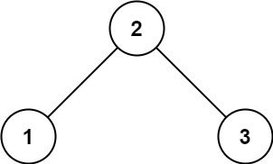

**Input:** root = [2,1,3]

**Output:** 1

**Example 2:**

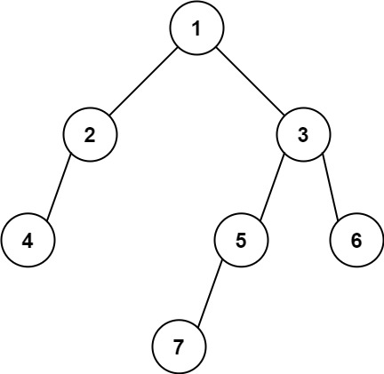

**Input:** root = [1,2,3,4,null,5,6,null,null,7]

**Output:** 7

**Constraints:**

* The number of nodes in the tree is in the range [1, 104].
* -231 <= Node.val <= 231 - 1

class Solution {

public:

    int findBottomLeftValue(TreeNode* root) {

        queue<TreeNode*> q;

        q.push(root);

        int leftmost_value;

        while (!q.empty()) {

            TreeNode* node = q.front();

            q.pop();

            leftmost_value = node->val;

            if (node->right) {

                q.push(node->right);

            }

            if (node->left) {

                q.push(node->left);

            }

        }

        return leftmost_value;

    }

};

Link : <https://leetcode.com/problems/find-bottom-left-tree-value/?envType=daily-question&envId=2024-02-28>